Ma. Khate beryl S. Saguid

BSI/T- 2F

Figure 1: Home of YouTube

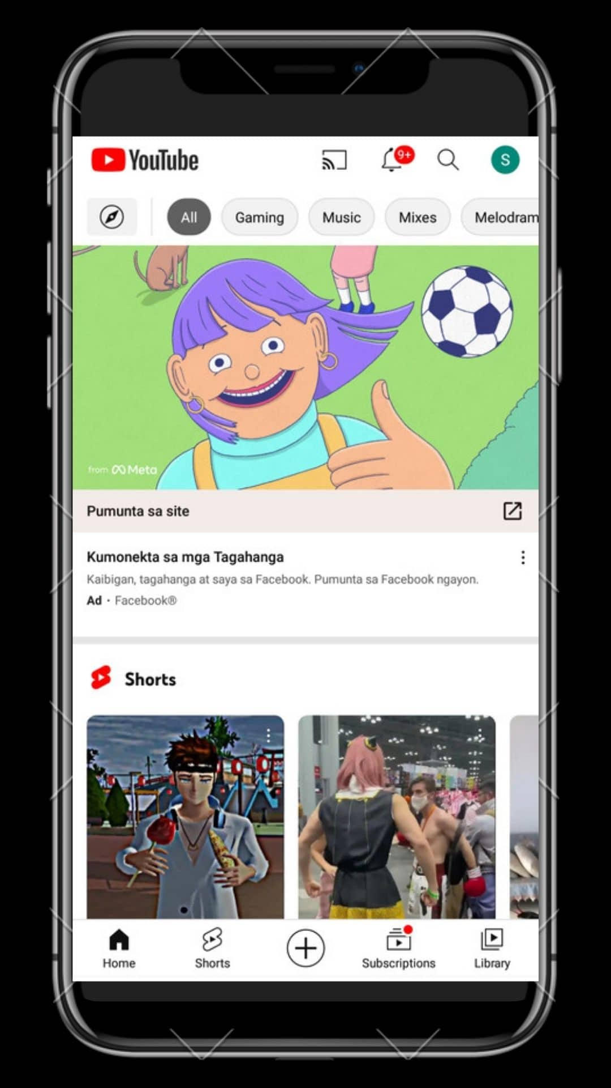

Figure 2: Shorts of YouTube

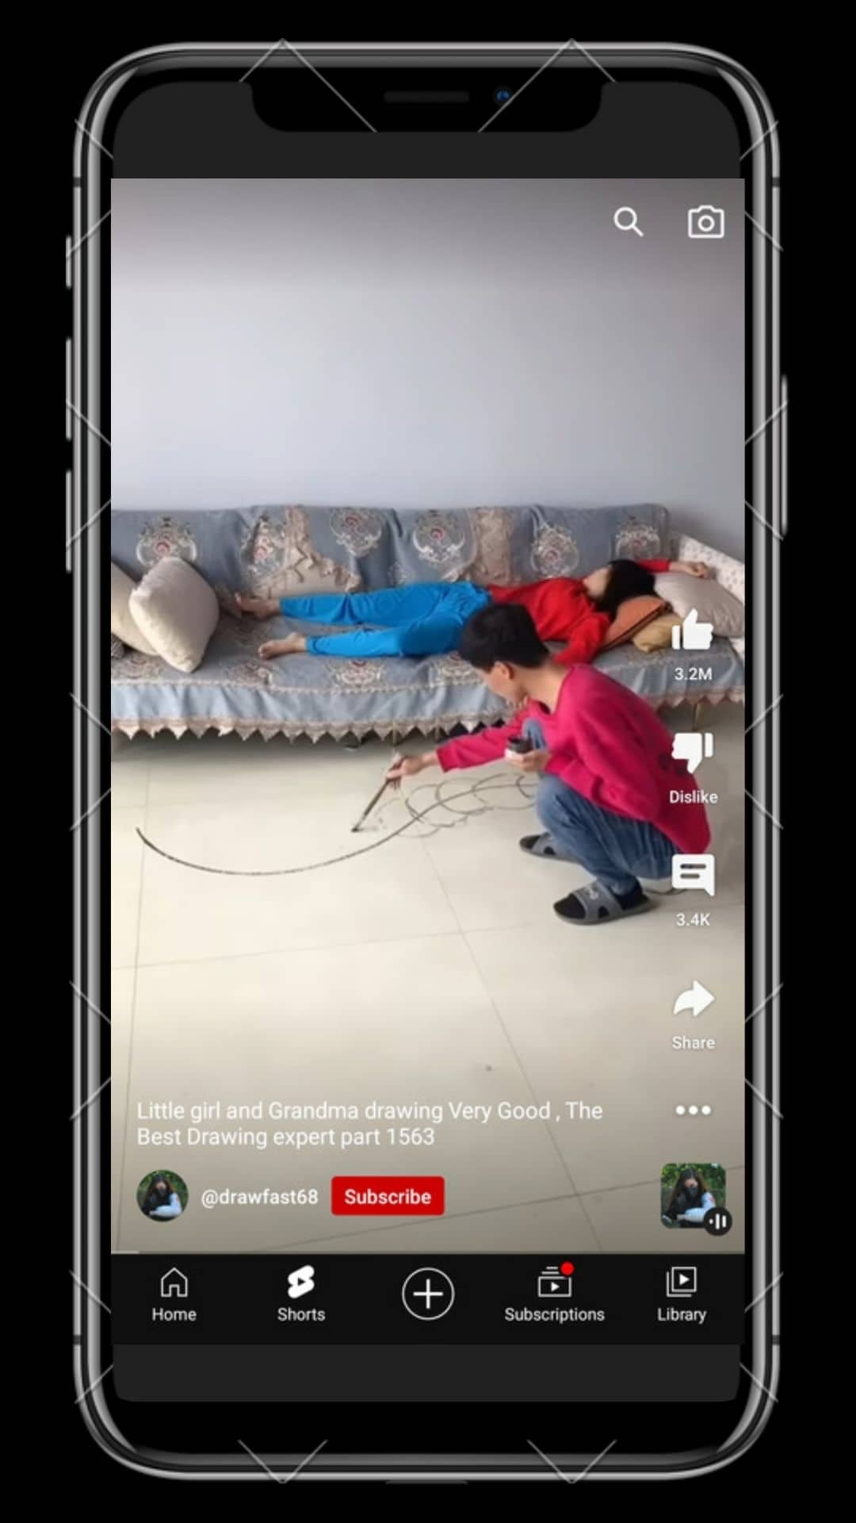

Figure 4: Create and post in Youtube

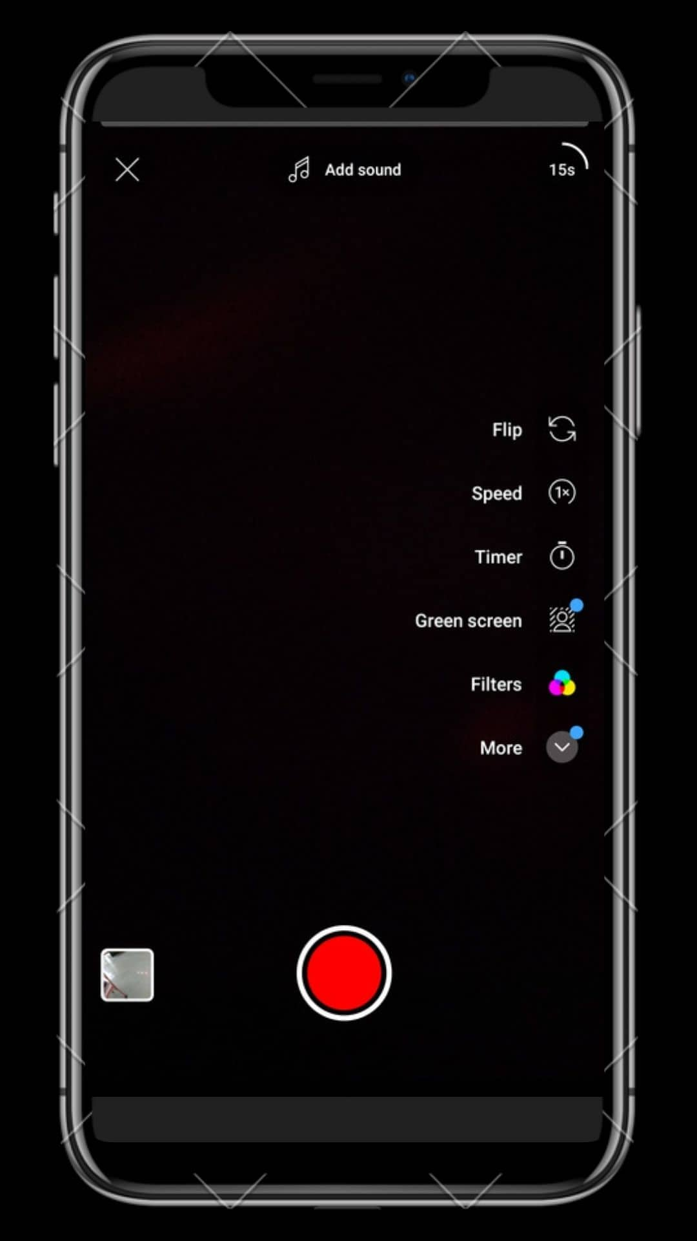

Figure 5: Subscribtion of YouTube

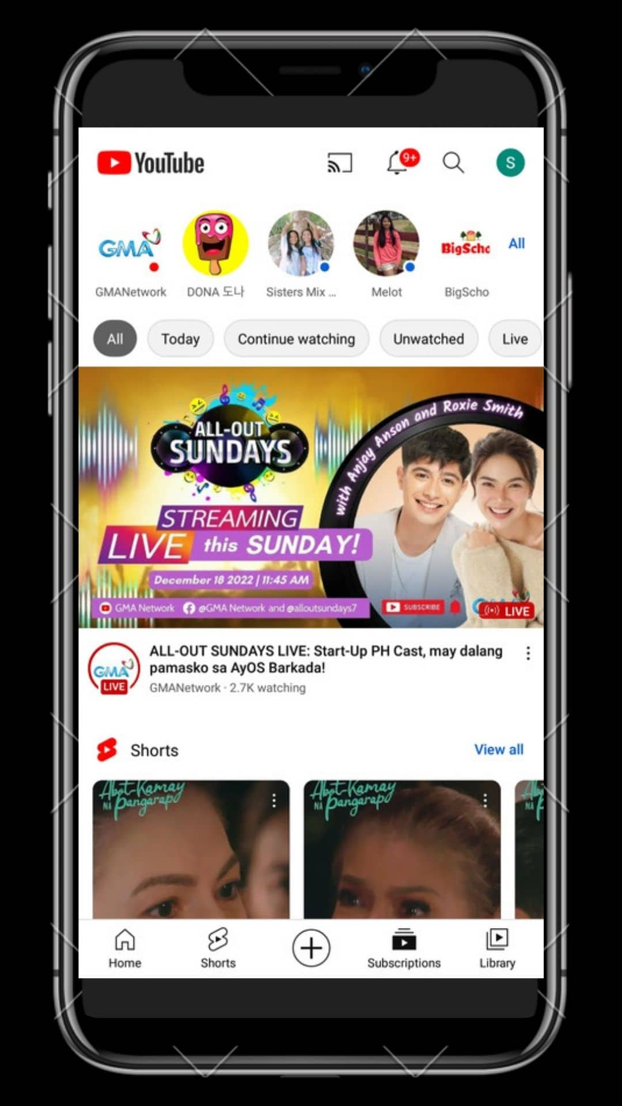

Figure 6: Library of YouTube

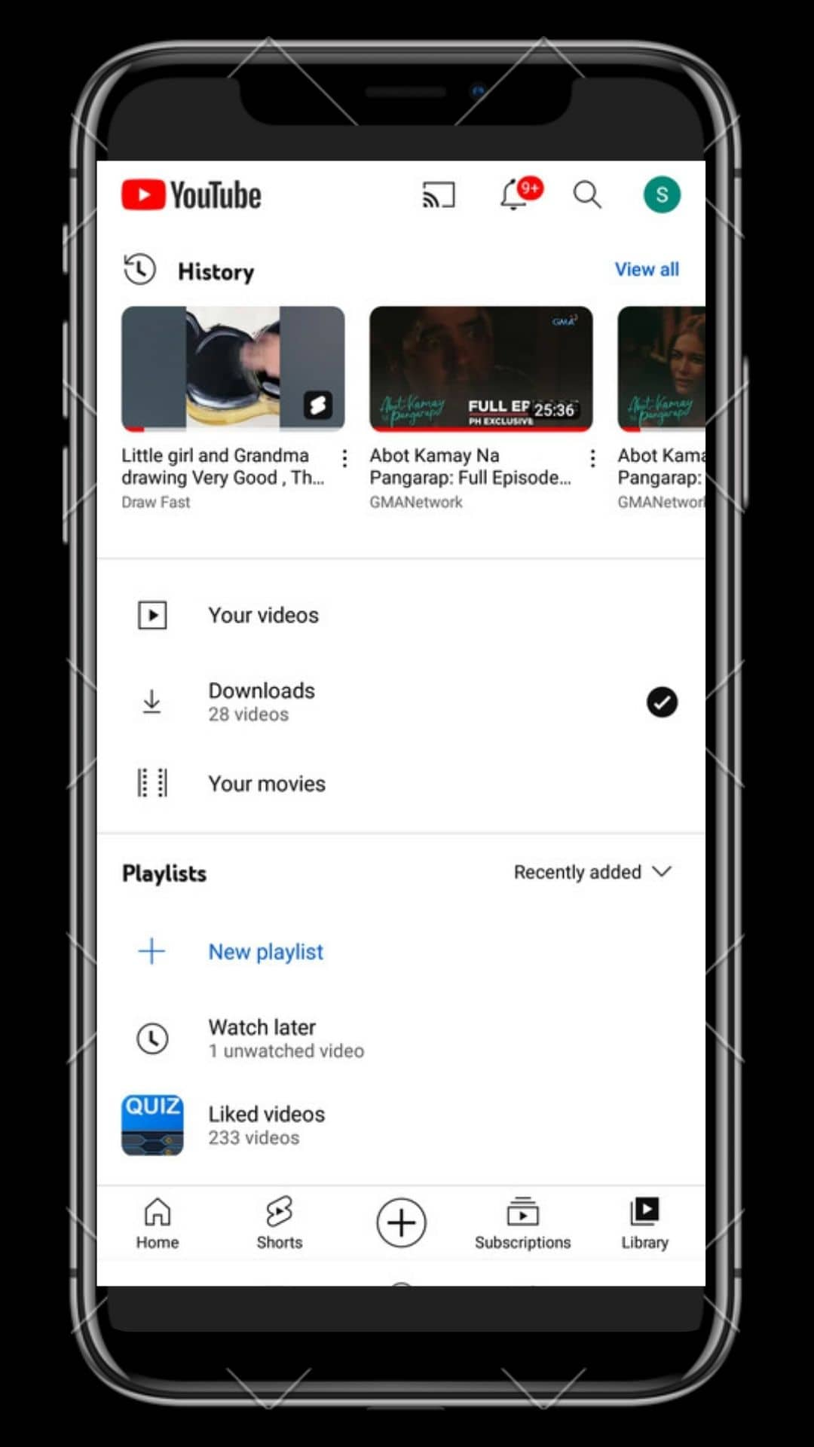

STRUCTURE OF YOUTUBE